DATE

01/10/2022

TEAM

ID

PNT2022TMID21718

TEAM

MEMBERS

4

PROJECT

NAME

WEB

PHISHING

DETECTION

**SOLUTION**

**ARCHITECTURE**

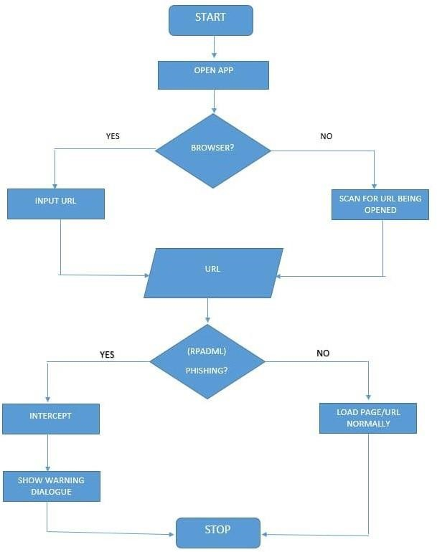

**SOLUTION**

**PROCESS**

